**Question No # 01: Bits of Revision (15)**

**1.** What are some common database constraints that can be used with DDL, and how do they

help to ensure data accuracy and consistency?

**SOLUTION:**

There are several common database constraints that can be used with Data Definition Language (DDL) to ensure data accuracy and consistency:

**Primary Key:**

A primary key constraint ensures that each record in a table is unique, and it prevents the insertion of duplicate data. This constraint helps maintain data accuracy and consistency by ensuring that each record can be uniquely identified.

**Foreign Key:**

A foreign key constraint ensures that a value in one table matches a value in another table. This constraint helps maintain data consistency by ensuring that only valid references are made between tables.

**Unique Constraint:**

A unique constraint ensures that each value in a column is unique, and it prevents the insertion of duplicate data. This constraint helps maintain data accuracy and consistency by ensuring that no two records have the same value for the specified column.

**Not Null Constraint:**

A not null constraint ensures that a column cannot contain null values. This constraint helps maintain data accuracy and consistency by ensuring that all required data is present in the table.

**Check Constraint:**

A check constraint ensures that a value in a column meets a specified condition. This constraint helps maintain data accuracy and consistency by ensuring that only valid data is entered into the table.

**2.** Create a schema that has students having option to enroll in multiple courses and the

courses can be repeated throughout the semesters.

**SOLUTION:**

Student Table:

- student_id (primary key)

- student_name

Course Table:

- course_id (primary key)

- course_name

Enrollment Table:

- enrollment_id (primary key)

- student_id (foreign key to Student table)

- course_id (foreign key to Course table)

- semester_number

**3.** Find all students who have taken a course multiple times, but in different semesters, and

list their names along with the name of the course and the total number of semesters in

which the course was taken (Use Created Schema).

**SOLUTION:**

SELECT s.student_name, c.course_name, COUNT(DISTINCT e.semester_number) as total_semesters

FROM Student s

JOIN Enrollment e ON s.student_id = e.student_id

JOIN Course c ON e.course_id = c.course_id

GROUP BY s.student_name, c.course_name

HAVING COUNT(*) > 1

**Question No # 02: Bits of Concept (25)**

**1.**  What type of query would we use to check whether two datasets in Database are equal and

Why?

**SOLUTION:**

To check whether two datasets in a database are equal, you would typically use a comparison query. Specifically, you would use a SELECT statement that retrieves the data from both datasets, and then compare the results to determine if they are the same.

**2.** Discuss join types in SQL covered in class, when would you use each one (general

scenario) and example query from slides only?

**SOLUTION:**

Aggregate functions can have issues with grouping, null values, and data types. To handle null values, you can use the COALESCE or IFNULL functions to replace null values with a default value before using the aggregate function.

**3.**  What are some potential issues to watch out when using Aggregate functions? How to

handle Null values using Aggregate functions.

**SOLUTION:**

Aggregate functions can have issues with grouping, null values, and data types. To handle null values, you can use the COALESCE or IFNULL functions to replace null values with a default value before using the aggregate function.

**4.**  Difference between Sub-Query, Nested-Query and Co-related Query. Provide when to use

each type and identification criteria for each type in given Query along with example.

(Tabular Notation).

**SOLUTION:**

**5.** What is a Role in Database and why is it efficient approach for assigning privileges?

**SOLUTION:**

A role in a database is a set of privileges or permissions that are granted to a group of users. It is an efficient approach for assigning privileges because it simplifies the process of managing access control and permissions, ensures consistency and security, and allows for easier management of user access by granting privileges to a group rather than to individual users.

**Question No # 03: First mention the type of Query and join (if using) then code it.**

**1.** You are provided with a SQL file attached. You have to create a Database “f21_XXXX”

having all the tables in the SQL.

**SOLUTION:**

Simply upload the sql file and run it.

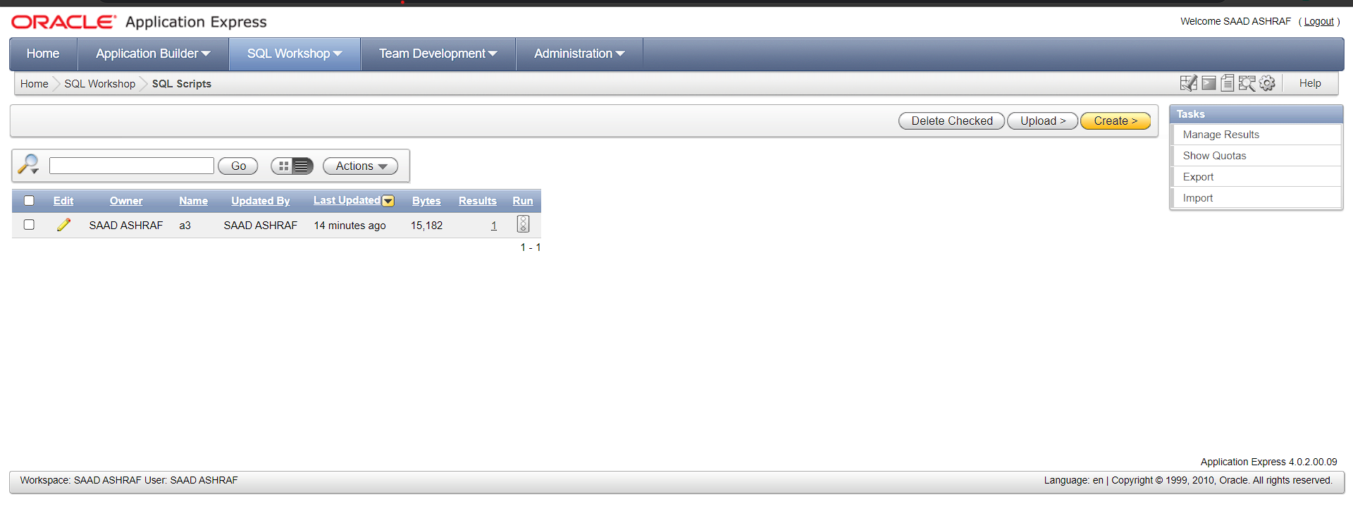

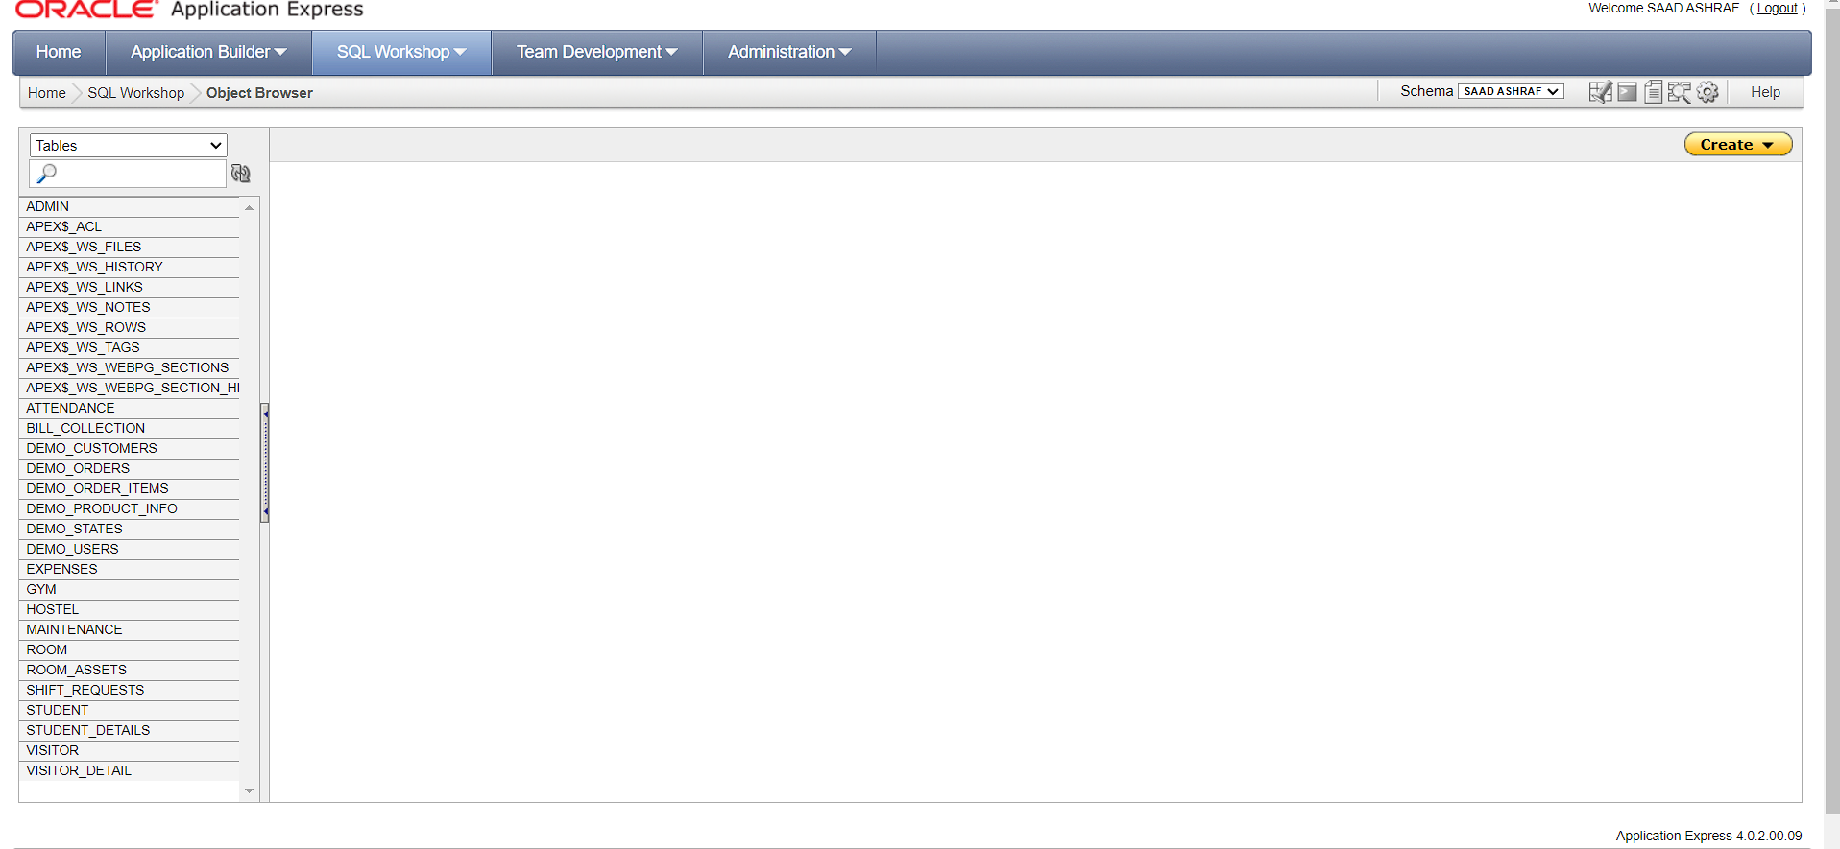

**2.**Find the names and phone numbers of all the visitors who have visited ‘Fatima’.

**SOLUTION:**

SELECT V.NAME, V1.contact, S.STDName

FROM VISITOR V

JOIN VISITOR_DETAIL V1 ON V.VID = V1.VD_ID

JOIN STUDENT S ON V.student_ID = S.student_ID

WHERE S.STDName = 'Fatima'

GROUP BY V.NAME, V1.contact, S.STDName;

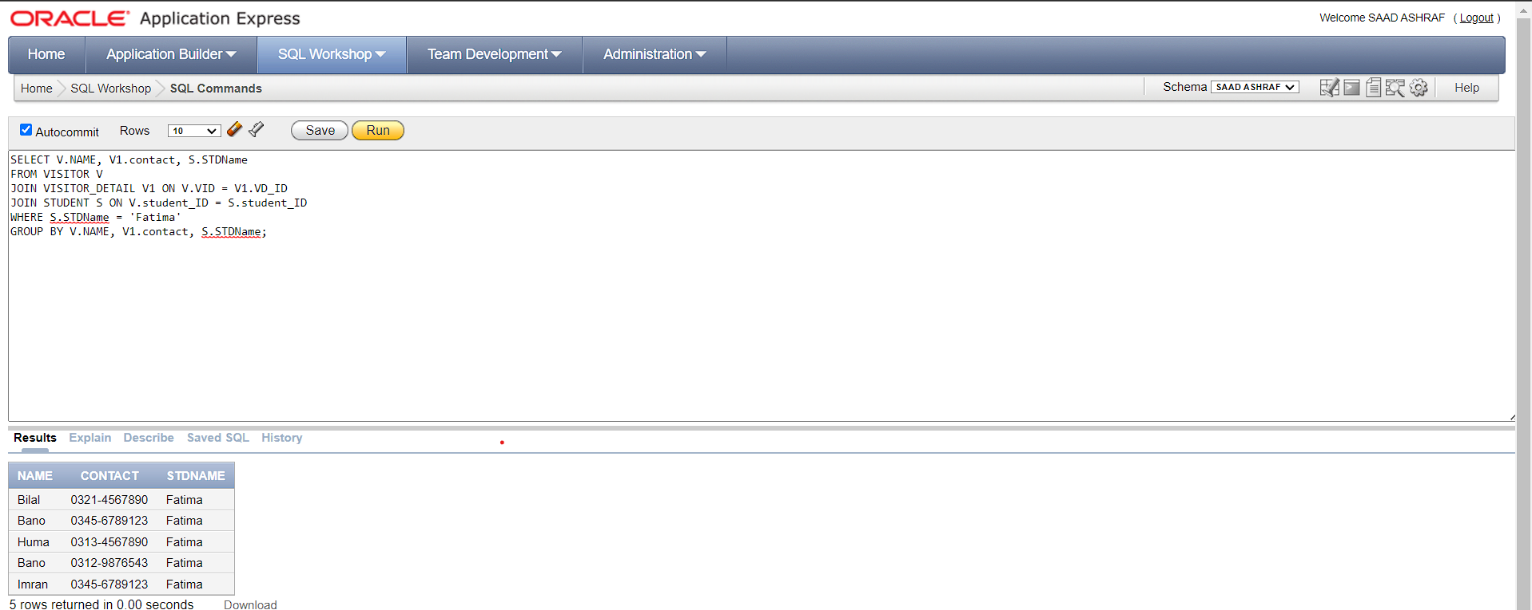

**3.**Find all pairs of students who have attended the gym together.

**SOLUTION:**

SELECT DISTINCT g1.student_id, g2.student_id

FROM gym g1

INNER JOIN gym g2 ON g1.join_date = g2.join_date

WHERE g1.student_id < g2.student_id

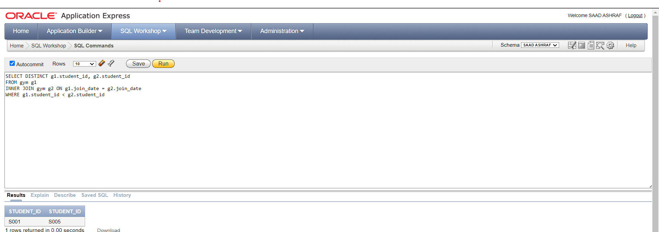

**4.**List the names of students who have not paid their gym dues for the current month.

**SOLUTION:**

SELECT s.STDNAME,g.JOIN_DATE

FROM STUDENT s,GYM g

WHERE s.STUDENT_ID=g.STUDENT_ID AND G.membership_status=0;

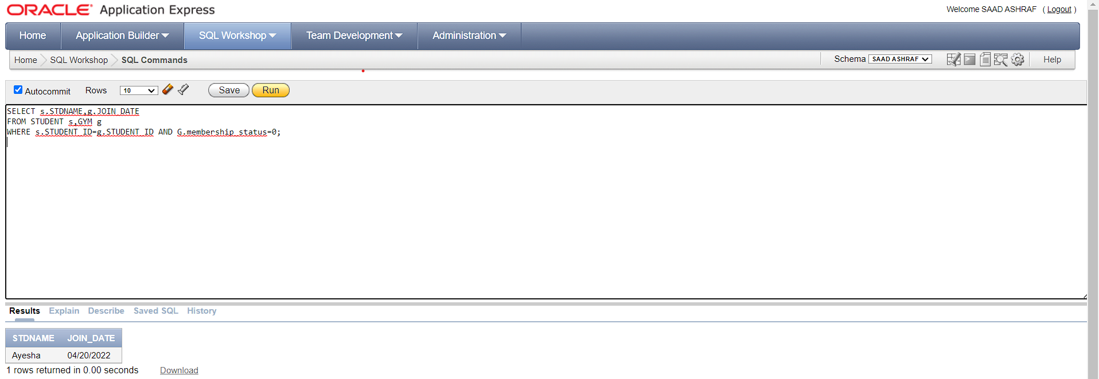

**5.**Return the details of all rooms that are currently vacant and their respective hostels.

**SOLUTION:**

SELECT *

FROM ROOM

WHERE STRENGTH=0;

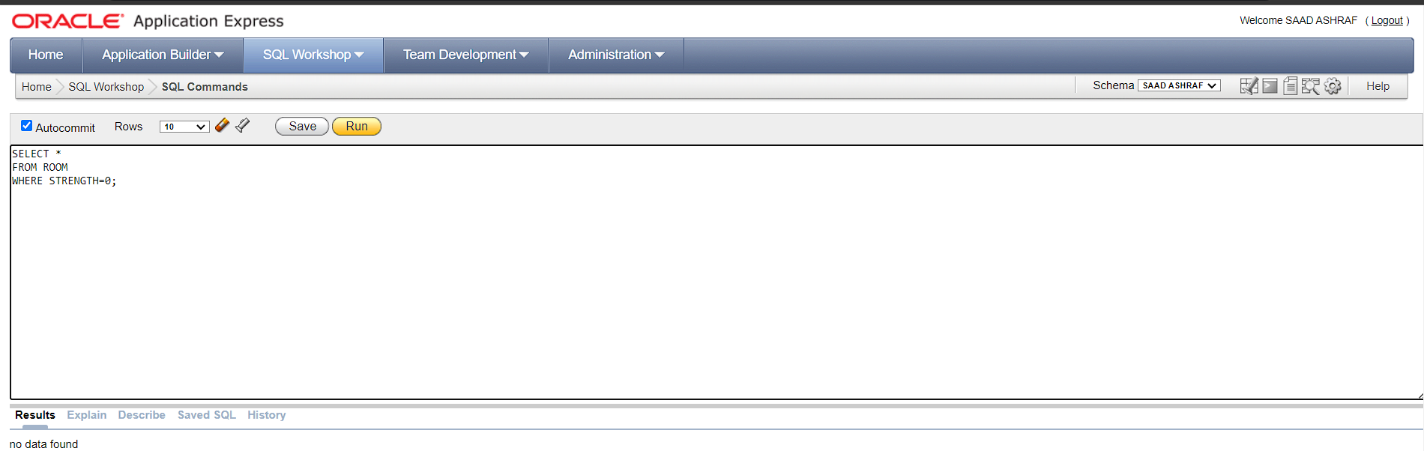

**6.**Return the details of all students who have visited by a visitor more than 3 times in the

past month.

**SOLUTION:**

SELECT s.*

FROM STUDENT s

WHERE s.STUDENT_ID IN (

SELECT v.STUDENT_ID

FROM VISITOR v

WHERE EXTRACT(MONTH FROM v.enter_time) = 3

GROUP BY v.STUDENT_ID, EXTRACT(DAY FROM v.enter_time)

HAVING COUNT(*) >= 3

);

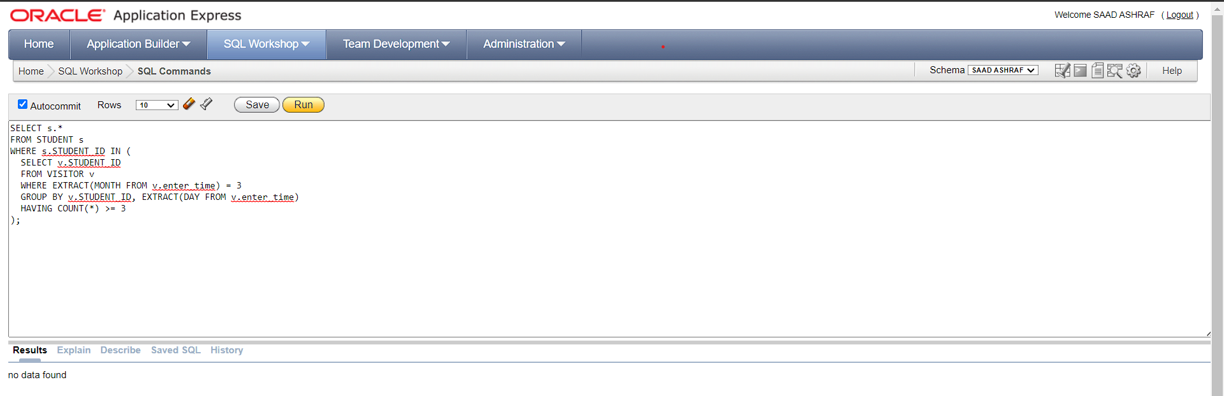

**7.**Select all maintenance expenses for '123 Main Street, Lahore hostel with in 1st Feb to 1st

March.

**SOLUTION:**

SELECT *

FROM EXPENSES e

INNER JOIN HOSTEL h ON e.hostel_ID = h.hostel_ID

WHERE h.Address = '123 Main Street, Lahore'

AND e.expense_date >= DATE '2022-02-01'

AND e.expense_date < DATE '2022-03-01'

AND e.TYPE='Maintenance';

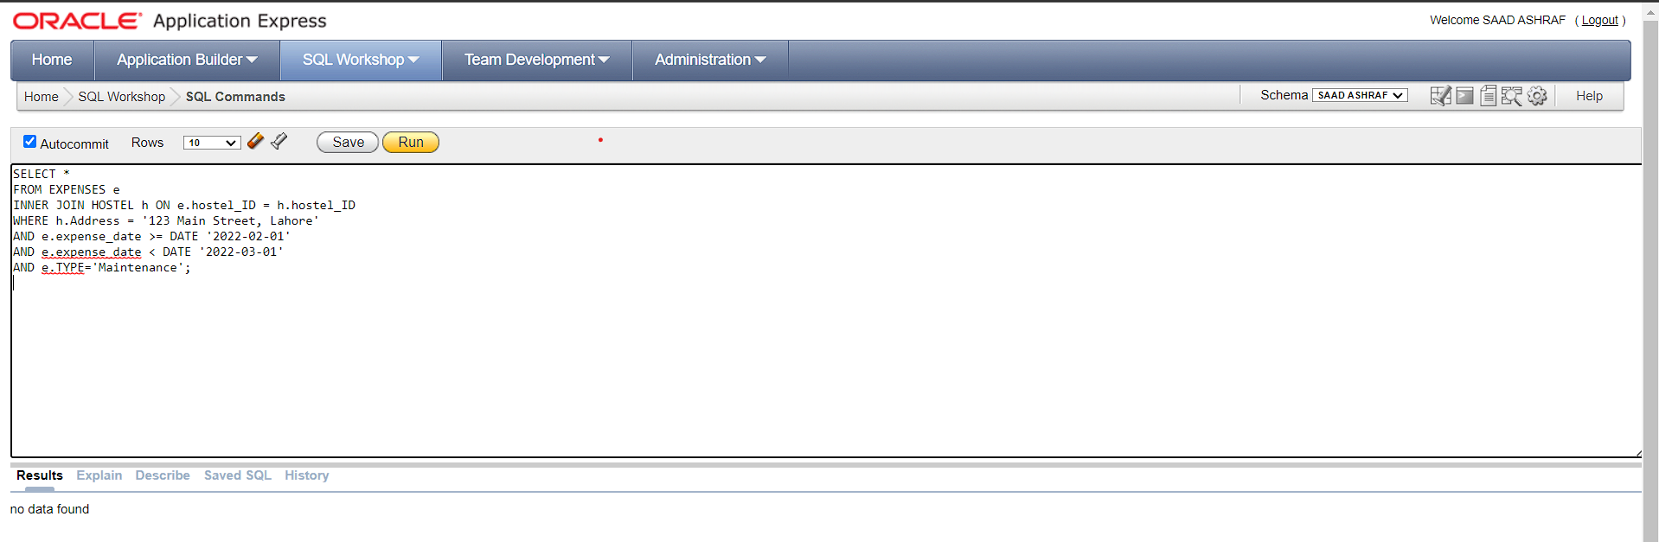

**8.**Retrieve a list of all the maintenance expenses for each hostel, including those hostels

with no maintenance expenses.

**SOLUTION:**

SELECT e.*

FROM Expenses e,Hostel H

WHERE H.HOSTEL_ID=E.HOSTEL_ID(+);

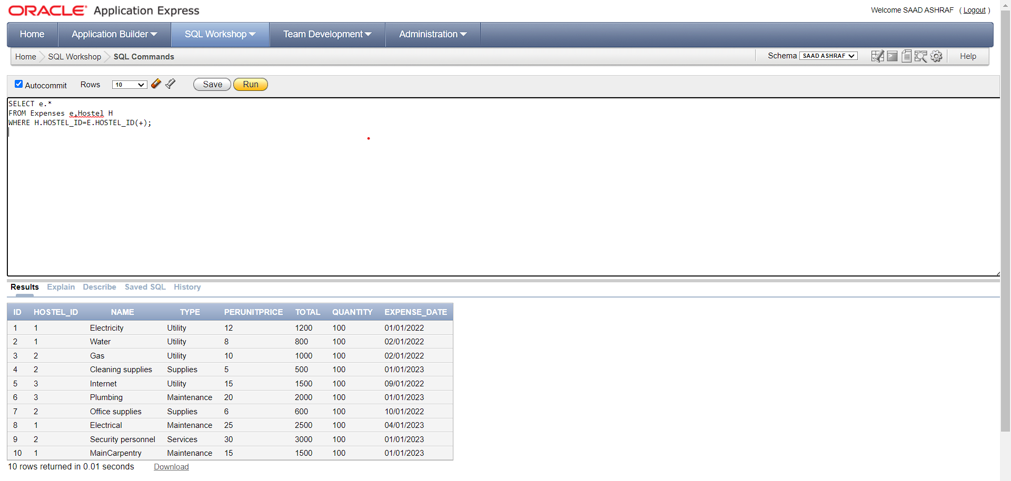

**9.**Retrieve a list of all the students and their corresponding visitor information, including

students without any visitors.

**SOLUTION:**

SELECT S.*,V.*

FROM STUDENT S,VISITOR V

WHERE S.Student_id=V.Student_id(+);

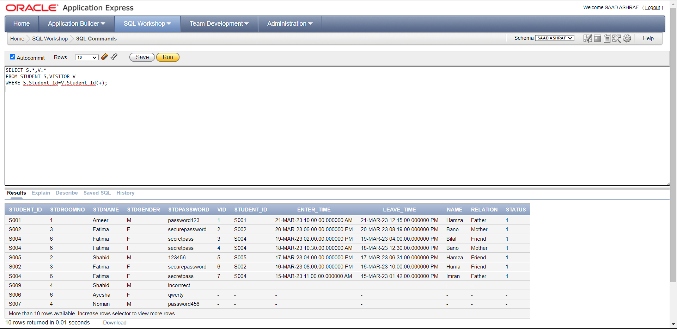

**10.** Display the name of the student who has the highest outstanding bill:

**SOLUTION:**

SELECT STDName

FROM STUDENT s, BILL_COLLECTION B

WHERE s.STUDENT_ID = B.stD_ID

AND B.outstanding = (SELECT MAX(outstanding) FROM BILL_COLLECTION);

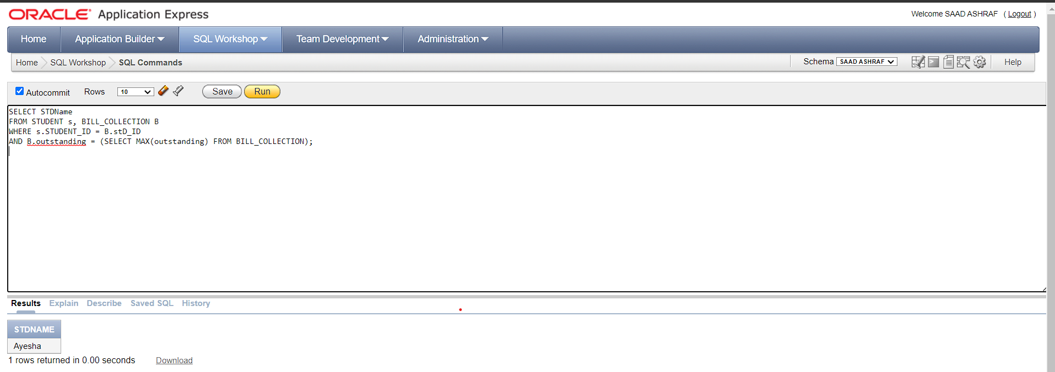

**11.** Show the names of students who have requested to swap rooms with another student.

**SOLUTION:**

SELECT STDName,R.REQUESTERID

FROM STUDENT s,SHIFT_REQUESTS R

WHERE R.REQUESTERID=s.STUDENT_ID ;

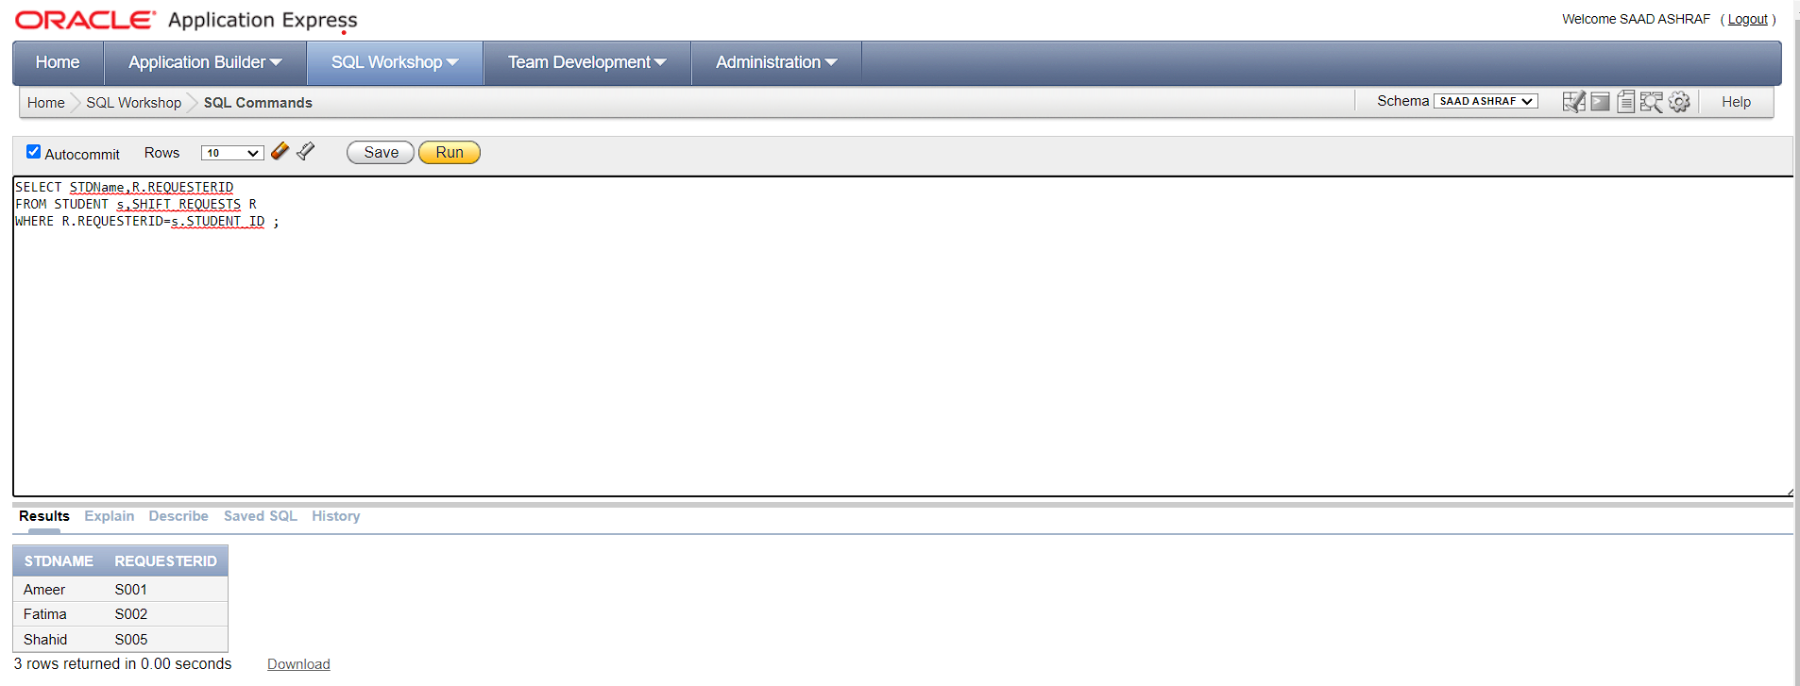

**12.** List all the visitors for “Ameer”, including their contact details.

**SOLUTION:**

SELECT v.*

FROM VISITOR v,STUDENT s

WHERE V.student_ID=S.student_ID AND S.STDName='Ameer';

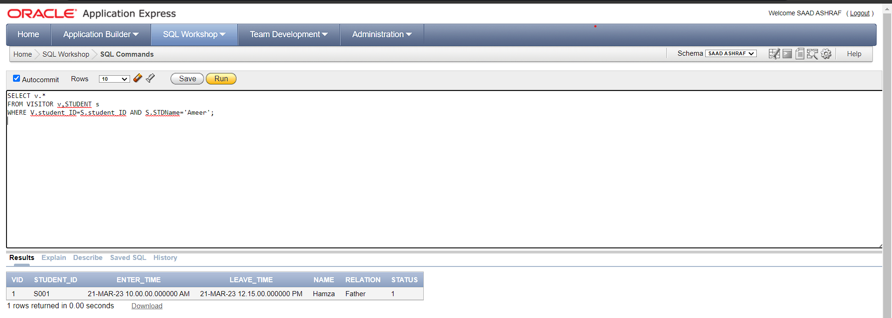

**13.** List the names of students who have attended gym but not paid their gym dues.

**SOLUTION:**

SELECT s.STDNAME,g.JOIN_DATE

FROM STUDENT s,GYM g

WHERE s.STUDENT_ID=g.STUDENT_ID AND G.membership_status=0;

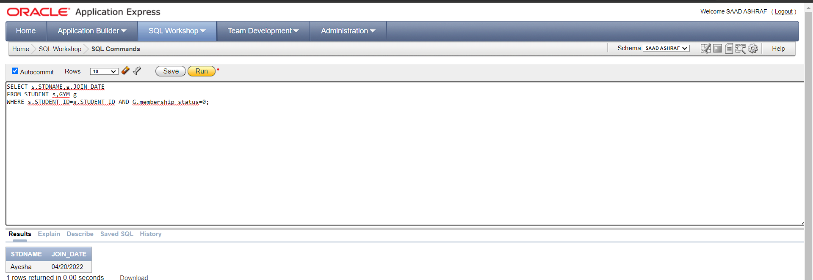

**14.** Find the visitors who stayed for the longest time in the hostel.

**SOLUTION:**

SELECT name, (leave_time - enter_time) as stay_duration

FROM VISITOR

WHERE leave_time - enter_time=(

SELECT MAX(leave_time - enter_time)

FROM VISITOR);

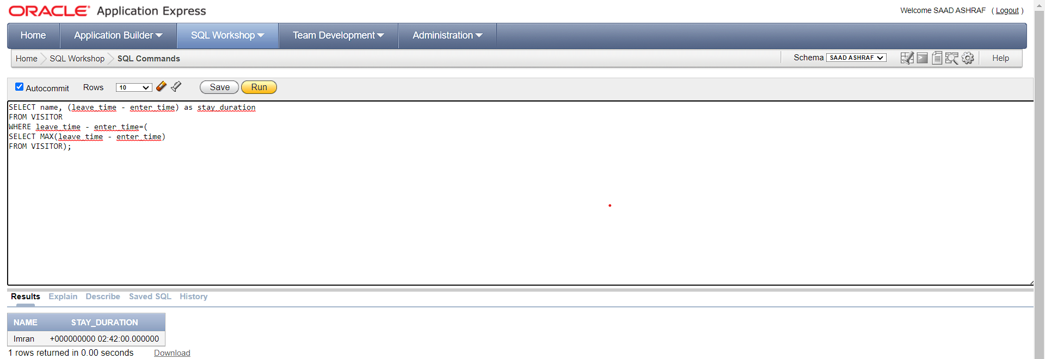

**15.** Select all students who have requested room shifts and the status of their requests.

**SOLUTION:**

SELECT s.STDName, R.REQUESTERID, R.STATUS

FROM SHIFT_REQUESTS R

INNER JOIN STUDENT s ON s.STUDENT_ID = R.REQUESTERID;

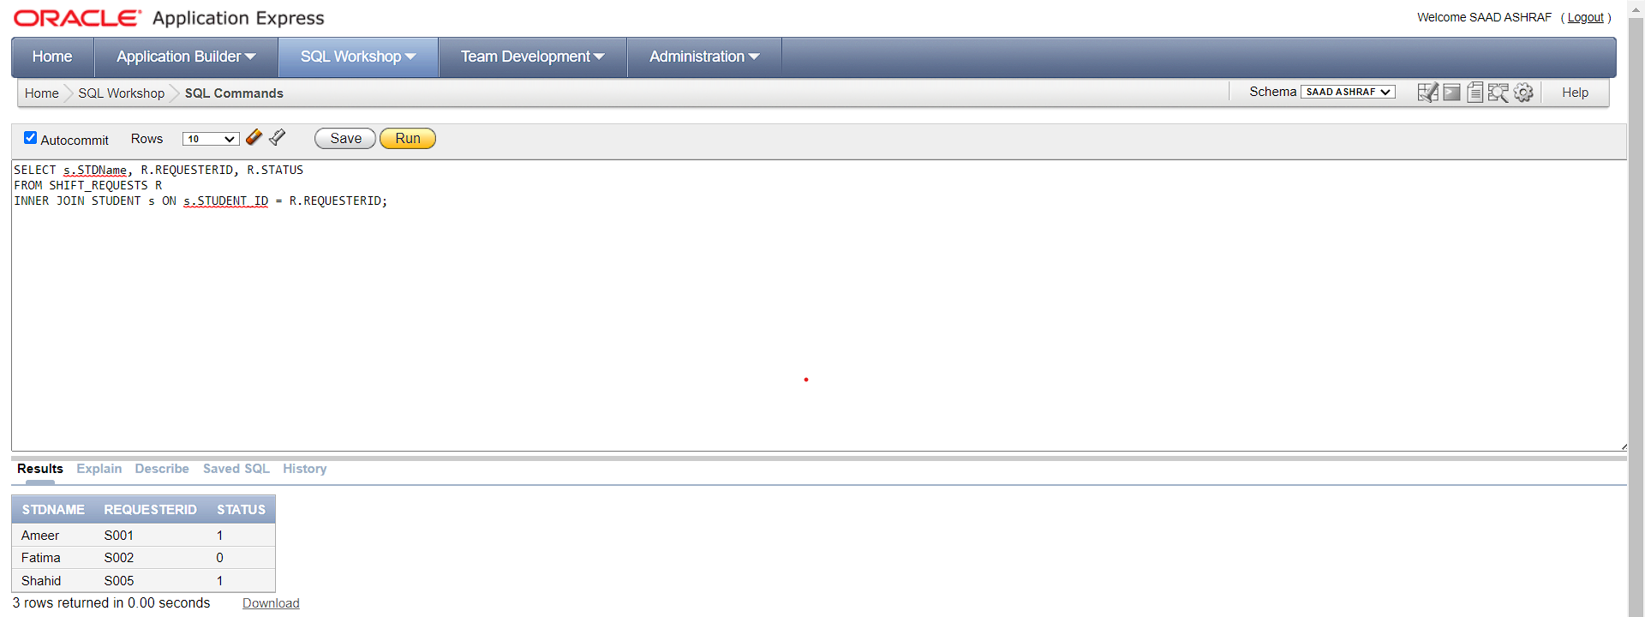

**16.** Find all the visitors who have the same name and relation.

**SOLUTION:**

SELECT DISTINCT V1.*

FROM VISITOR V1

INNER JOIN VISITOR V2

ON V1.NAME = V2.NAME

AND V1.RELATION = V2.RELATION

AND V1.STUDENT_ID != V2.STUDENT_ID;

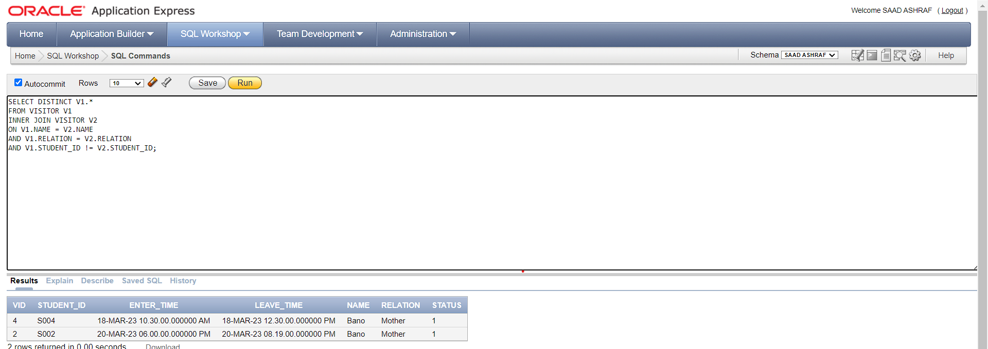

**17.** Find all students who have the same name.

**SOLUTION:**

SELECT S.* FROM STUDENT S, STUDENT S1

WHERE S.STDName=S1.STDName AND S.student_ID!=S1.student_ID

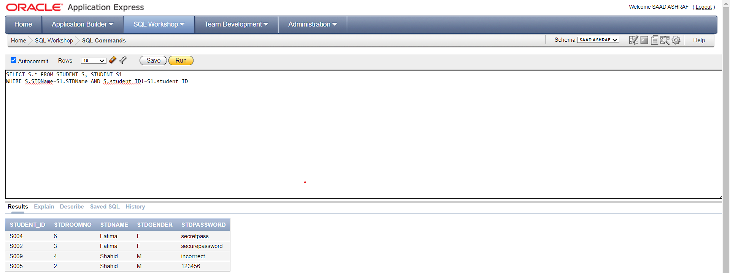

**18.** Find the student names and their respective bill details (including current and outstanding

bill amounts) for the month of March, 2023.

**SOLUTION:**

SELECT S.STDName, B.*

FROM STUDENT S

INNER JOIN BILL_COLLECTION B ON S.student_ID = B.stD_ID

WHERE B.currentBillingMonth = 'March';

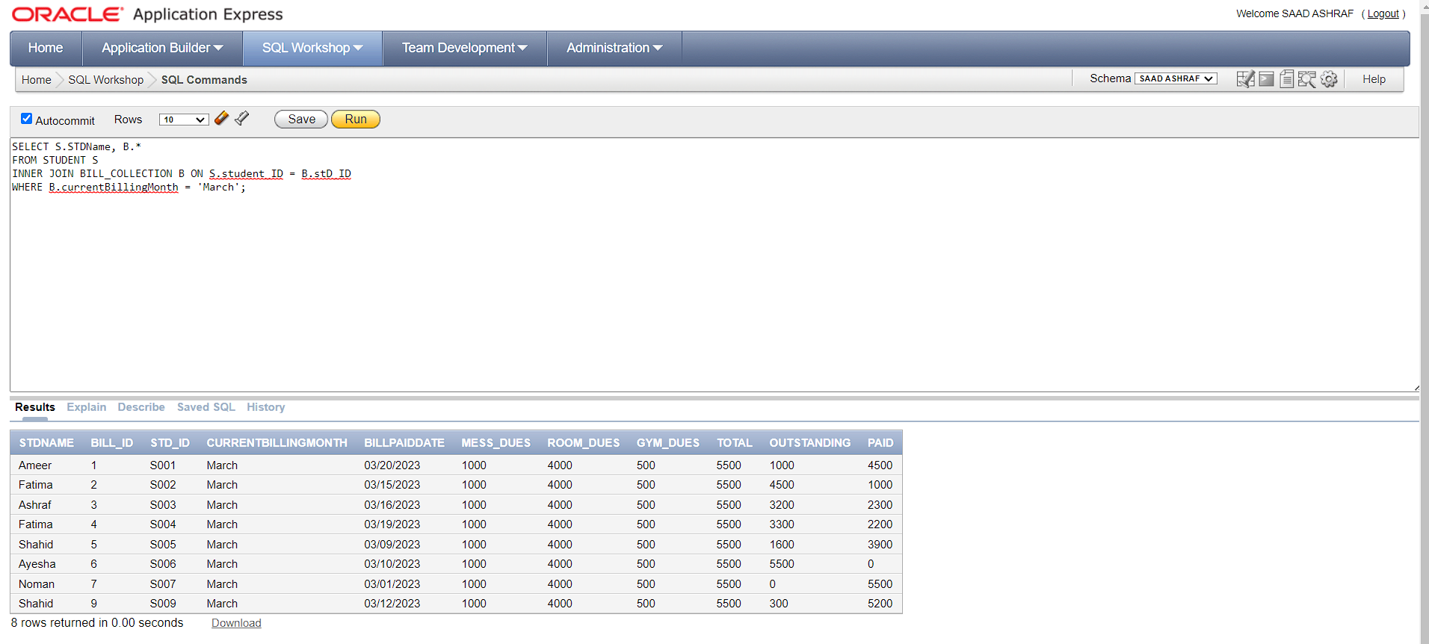

**19.** Find the student names who have paid all their bills and have not been visited by any

visitor in the last month.

**SOLUTION:**

SELECT S.STDName,B.OUTSTANDING

from STUDENT s,BILL_COLLECTION B,VISITOR V

WHERE S.student_ID(+)=B.stD_ID AND V.student_ID(+)=S.student_ID AND B.OUTSTANDING=0 ;

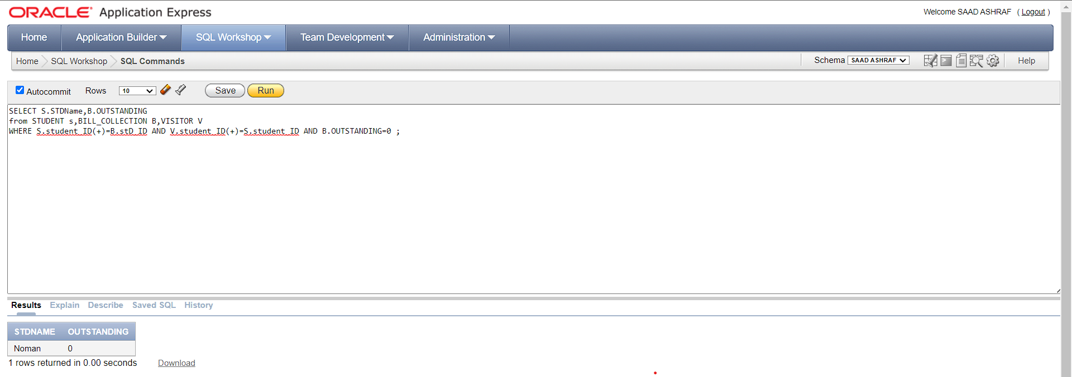

**20.** Find all students who have more than one visitor in the system.

**SOLUTION:**

SELECT S.STUDENT_ID

FROM STUDENT S

WHERE S.STUDENT_ID IN (

SELECT V.STUDENT_ID

FROM VISITOR V

GROUP BY V.STUDENT_ID

HAVING COUNT(V.STUDENT_ID) > 1

);

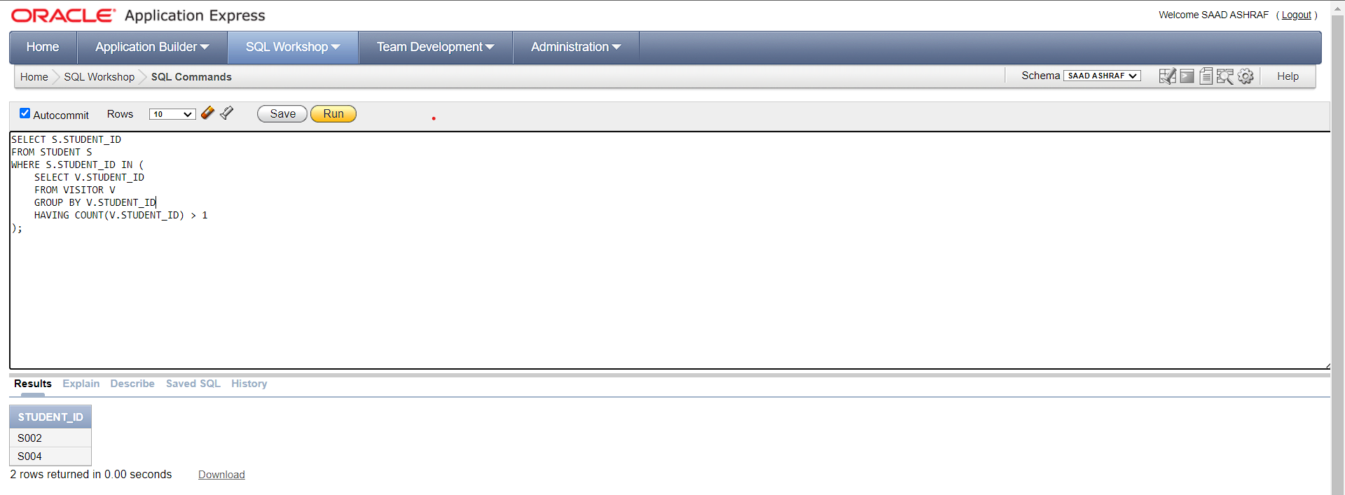

**21.** Find the total rent paid by students who have a gym membership.

**SOLUTION:**

SELECT SUM(R.PAID)

FROM BILL_COLLECTION R

INNER JOIN STUDENT S ON S.STUDENT_ID = R.STD_ID

INNER JOIN GYM G ON G.STUDENT_ID = S.STUDENT_ID

WHERE G.MEMBERSHIP_STATUS = 1;

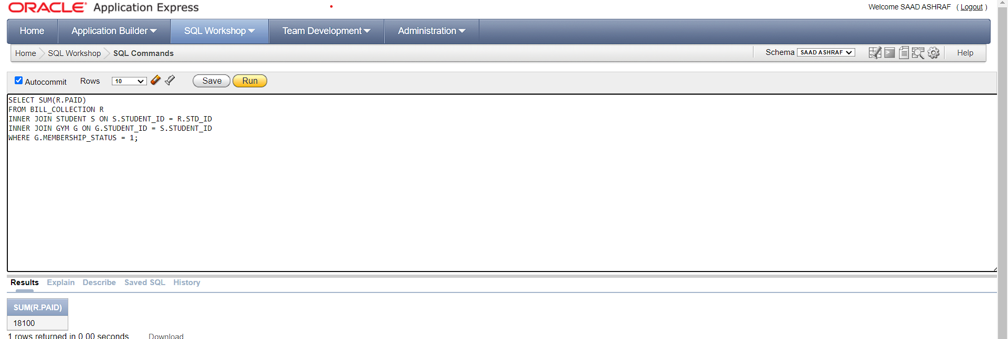

**22.**Retrieve the name and type of all expenses incurred by Boys Hostel in a February.

**SOLUTION:**

SELECT E.NAME

FROM EXPENSES e,HOSTEL H

WHERE e.HOSTEL_ID=H.HOSTEL_ID

AND e.expense_date >= DATE '2022-02-01'

AND e.expense_date < DATE '2022-04-01'AND RESIDENCY_TYPE='Boys Hostel';

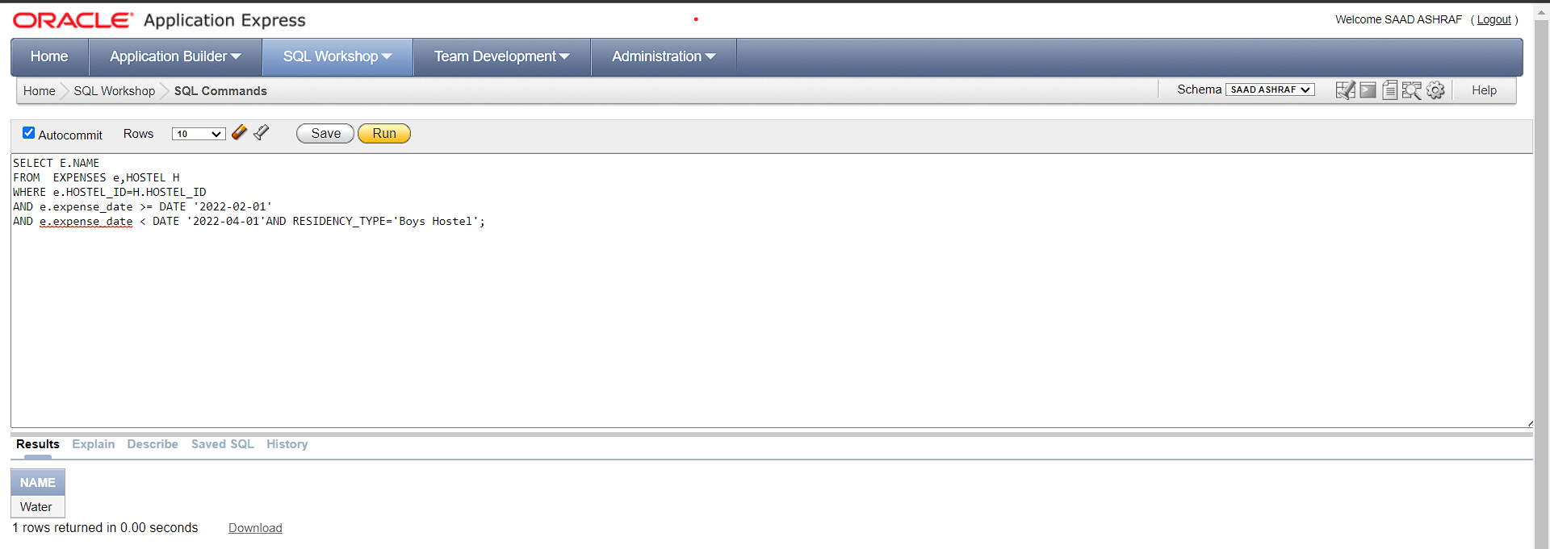

**23.** Display the hostel IDs and their corresponding total expenses concatenated with a '$'

symbol at the beginning, where the expenses are incurred in the current year.

**SOLUTION:**

SELECT Hostel_id,CONCAT('$',sum(total))

from expenses

where Extract(year from expense_date)=2023

group by hostel_id;

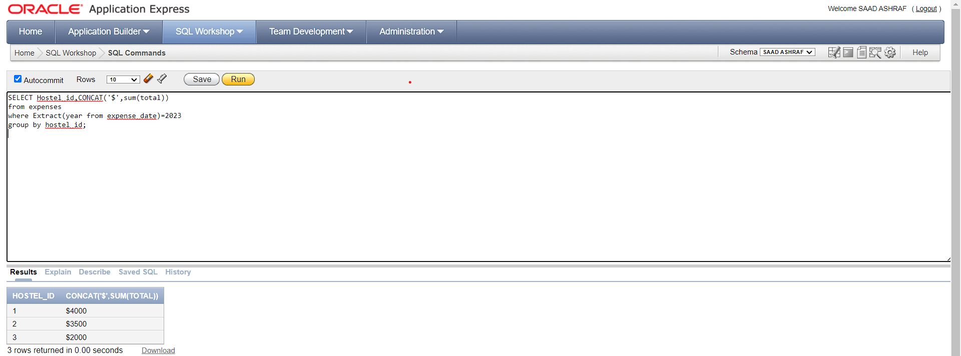

**24.**Find all pairs of students who live in adjacent rooms on the same floor.

**SOLUTION:**

SELECT s1.STDName as Student1, s2.STDName as Student2,R1.ROOMNO

FROM STUDENT s1

JOIN ROOM r1 ON s1.STDRoomNo = r1.RoomNo

JOIN ROOM r2 ON r1.Floors = r2.Floors AND r1.RoomNo <> r2.RoomNo AND ABS(r1.RoomNo - r2.RoomNo) = 1

JOIN STUDENT s2 ON s2.STDRoomNo = r2.RoomNo;

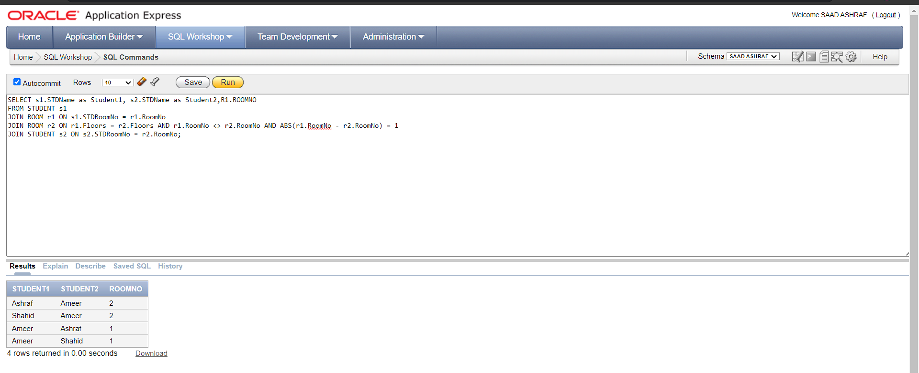

**25.** Get the Resident Type and addresses of all hostels, as well as the room numbers and rental

fees for rooms that can accommodate a minimum of two individuals.

**SOLUTION:**

SELECT H.RESIDENCY_TYPE, H.ADDRESS, R.RENT, R.ROOMNO

FROM HOSTEL H

INNER JOIN ROOM R ON H.HOSTEL_ID = R.HOSTEL_ID

WHERE R.CAPACITY >= 2;

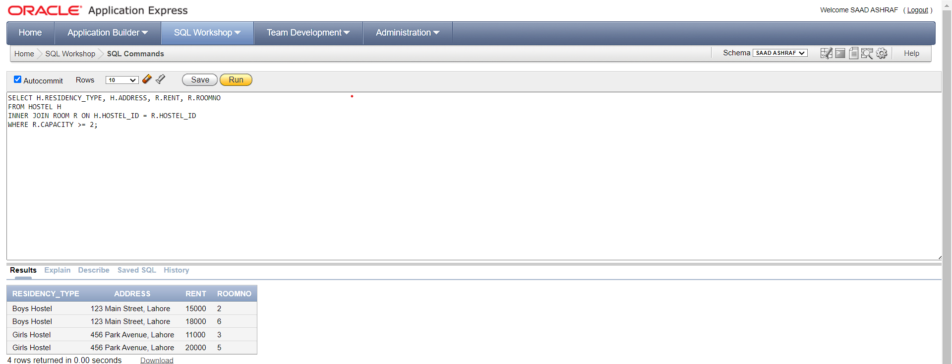

**26.** Find the total number of expenses for each hostel.

**SOLUTION:**

SELECT H.HOSTEL_ID, COUNT(E.TOTAL)

FROM HOSTEL H,EXPENSES E

WHERE H.HOSTEL_ID = E.HOSTEL_ID

GROUP BY H.HOSTEL_ID;

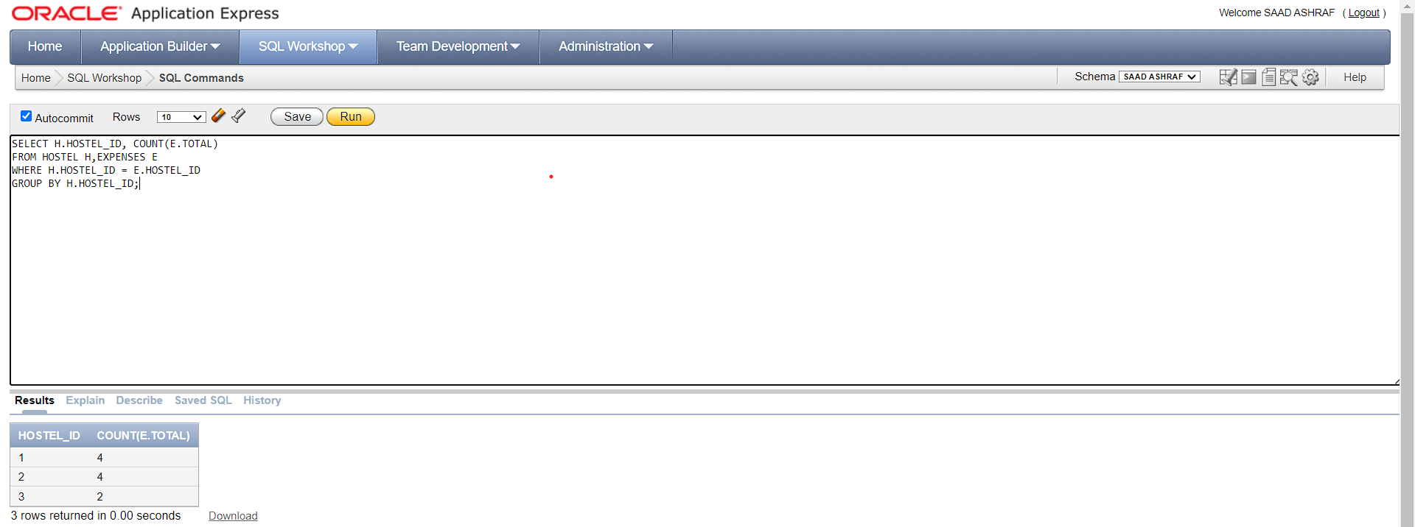

**27.** Find the name of the hostel with the highest number of expenses in the current month.

**SOLUTION:**

SELECT H.RESIDENCY_TYPE, E2.TOTAL

FROM HOSTEL H

JOIN EXPENSES E2 ON H.HOSTEL_ID = E2.HOSTEL_ID

WHERE E2.TOTAL = (

SELECT MAX(E2.TOTAL)

FROM EXPENSES E2

WHERE EXTRACT(MONTH FROM E2.expense_date) = 3

);

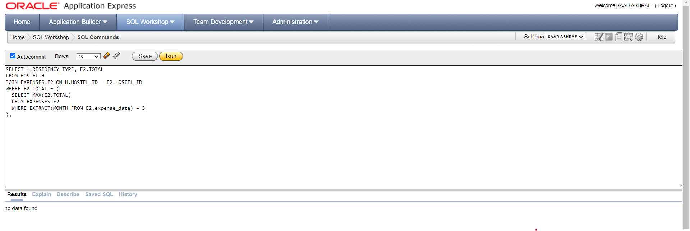

**28.**Display the student IDs and their corresponding gym membership statuses, where the

student has a valid gym membership and their room type is 'Double'.

**SOLUTION:**

SELECT S.STUDENT_ID, G.MEMBERSHIP_STATUS

FROM STUDENT S

JOIN GYM G ON S.STUDENT_ID = G.STUDENT_ID

JOIN ROOM R ON S.STDROOMNO = R.ROOMNO

WHERE R.ROOMTYPE = 'Shared' AND G.MEMBERSHIP_STATUS = 1;

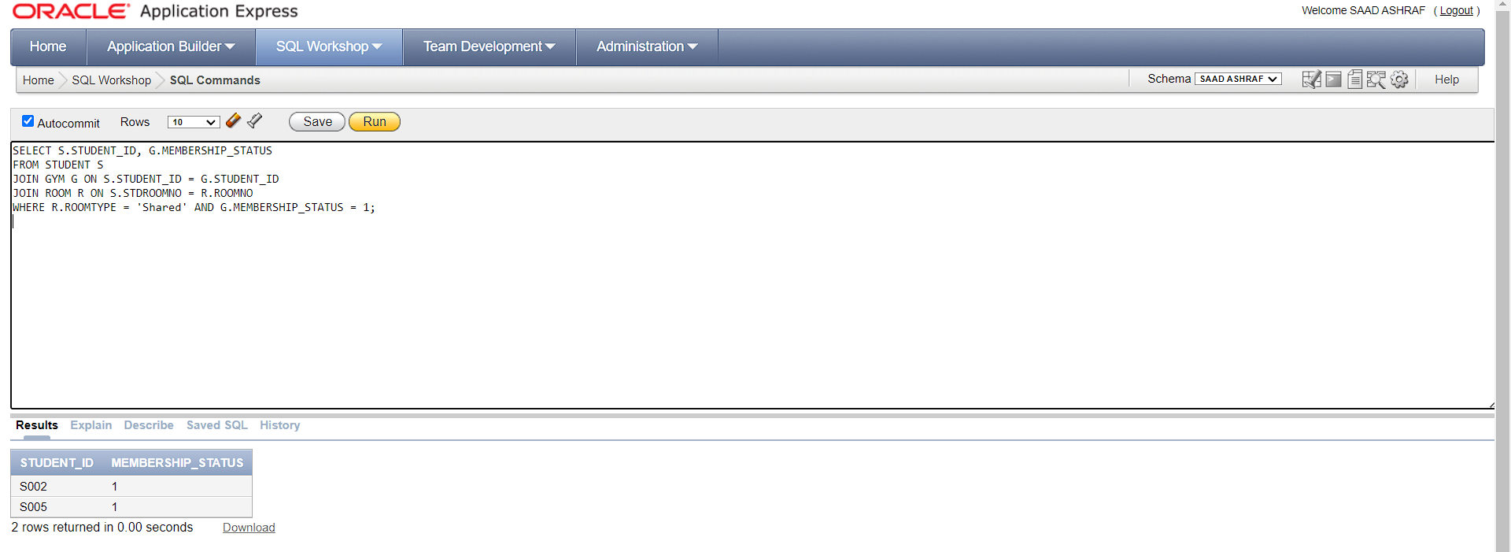

**29.** Find the names of students who have requested a room swap with a student who has not

yet paid their bills for the current month.

**SOLUTION:**

SELECT S.STDNAME

FROM STUDENT S

JOIN BILL_COLLECTION B ON S.STUDENT_ID = B.STD_ID

JOIN SHIFT_REQUESTS R ON S.STUDENT_ID = R.SWAPPERID

WHERE B.PAID = 0 AND B.CURRENTBILLINGMONTH = 'MARCH';

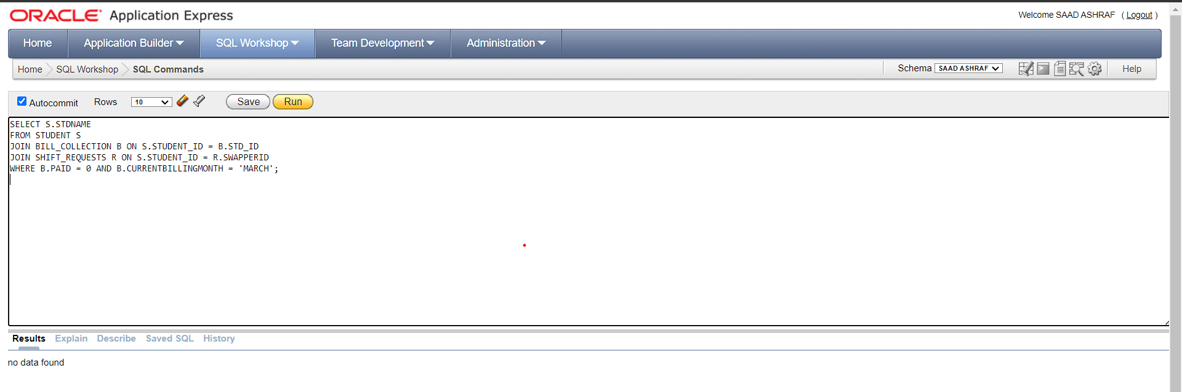

**30.**Find the student with the highest number of bills paid in the current billing month.

**SOLUTION:**

SELECT STD_ID,PAID

FROM BILL_COLLECTION

WHERE PAID=(

SELECT MAX(PAID)

FROM BILL_COLLECTION);

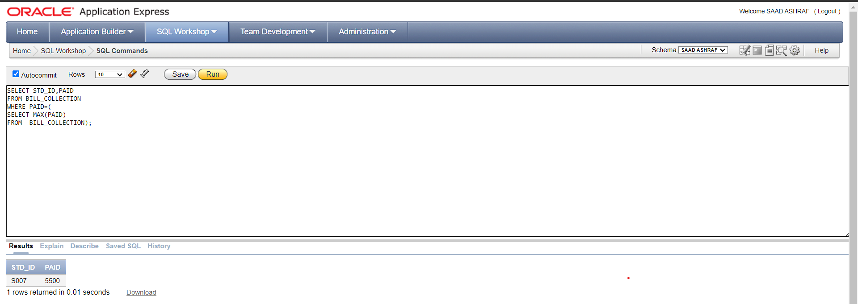

**Question No # 04:**

You have to use Union and Intersection in all of the Queries.

**1.** Get a list of all the students who have outstanding dues in the bill collection table or who

have a gym membership in the gym table.

**SOLUTION:**

SELECT s.*

FROM STUDENT s

WHERE STUDENT_ID IN (

SELECT STD_ID

FROM BILL_COLLECTION

WHERE OUTSTANDING != 0

)

UNION

SELECT s.*

FROM STUDENT s

WHERE STUDENT_ID IN (

SELECT STUDENT_ID

FROM GYM

WHERE MEMBERSHIP_STATUS = 1

);

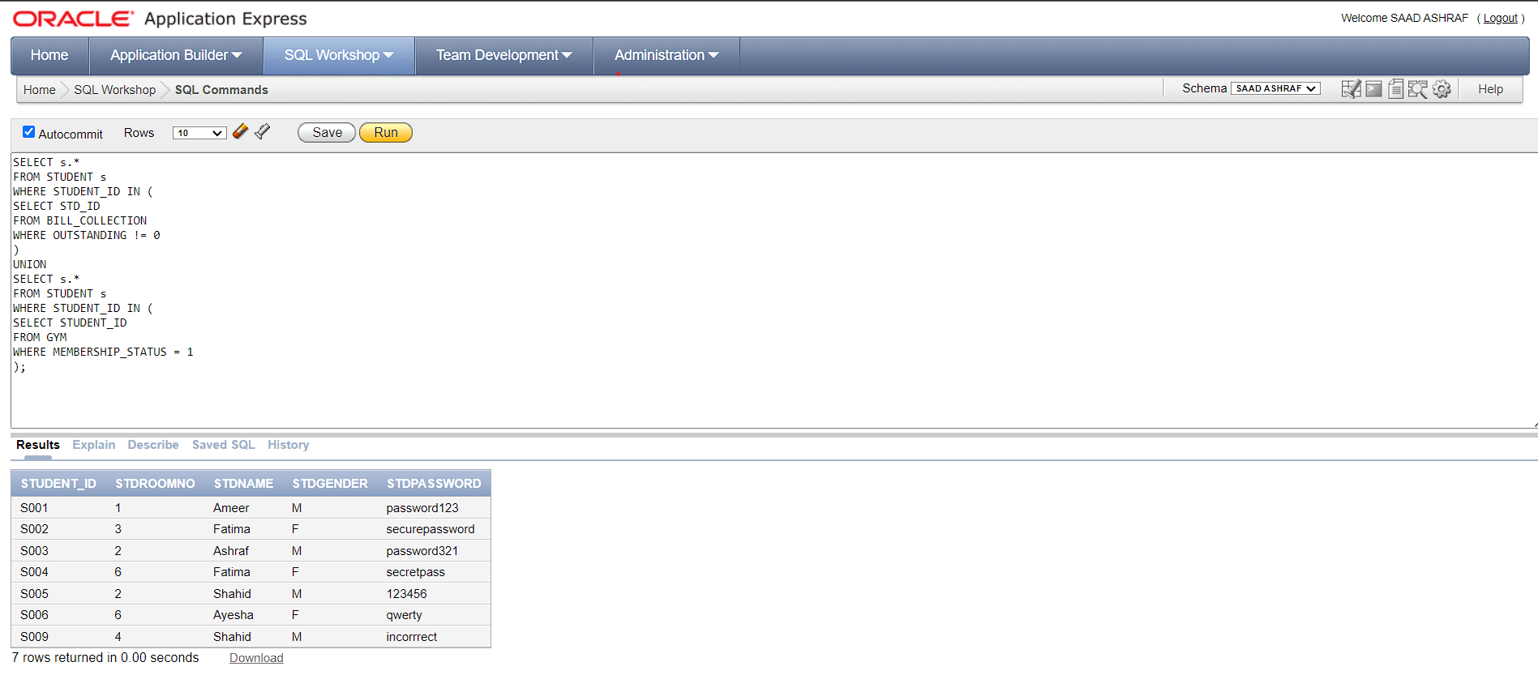

**2.** Get a list of all the students who have outstanding dues and whose billing month is the

current month in the bill collection table.

**SOLUTION:**

SELECT s.*

FROM STUDENT s

WHERE S.STUDENT_ID IN(

SELECT STD_ID

FROM BILL_COLLECTION

WHERE OUTSTANDING!=0)

INTERSECT

SELECT s.*

FROM STUDENT s

WHERE S.STUDENT_ID IN(

SELECT STD_ID

FROM BILL_COLLECTION

WHERE CURRENTBILLINGMONTH='March');

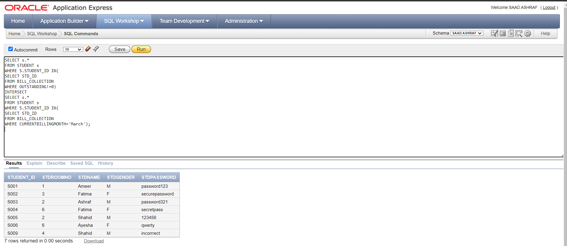

**3.** Get a list of all the students who have visitors and whose visitor's relation is "friend".

**SOLUTION:**

SELECT S.*

FROM STUDENT S

WHERE S.STUDENT_ID IN (

SELECT STUDENT_ID

FROM VISITOR

)

INTERSECT

SELECT S.*

FROM STUDENT S

WHERE S.STUDENT_ID IN (

SELECT STUDENT_ID

FROM VISITOR

WHERE RELATION = 'Friend'

);

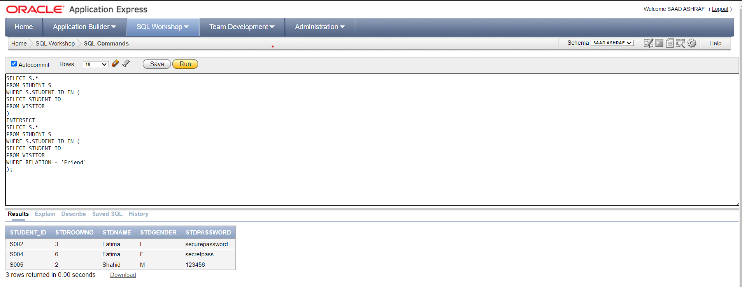

**4.** Get a list of all the unique room types in the room table and the unique designation in the

admin table.

**SOLUTION:**

SELECT DISTINCT ROOMTYPE AS_ROOM

FROM ROOM

UNION

SELECT DISTINCT DESIGNATION AS ADMIN_DES

FROM ADMIN;

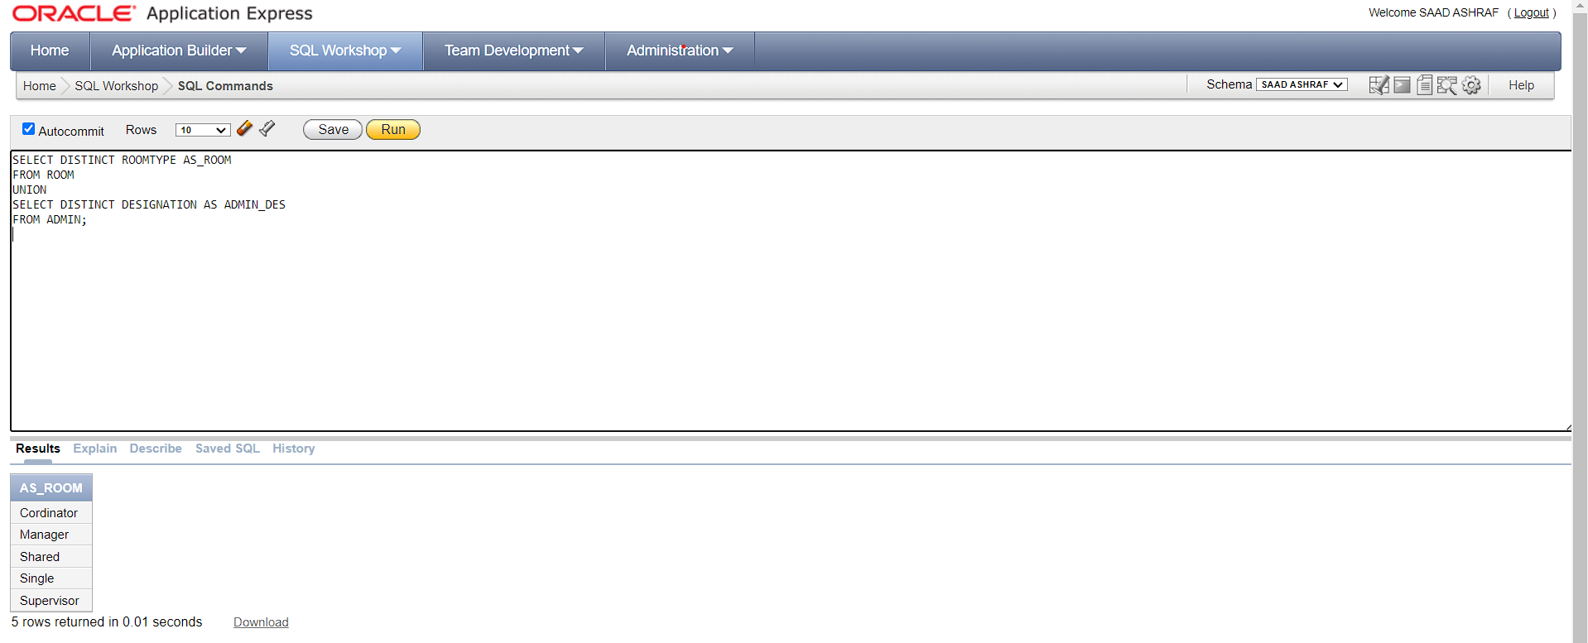

**5.** Find the names of all students who have visited the hostel as visitors and have also joined

**SOLUTION:**

SELECT S.STUDENT_ID

FROM STUDENT S

WHERE S.STUDENT_ID IN(

SELECT STUDENT_ID

FROM VISITOR

)

INTERSECT

SELECT S.STUDENT_ID

FROM STUDENT S

WHERE S.STUDENT_ID IN(

SELECT S.STUDENT_ID

FROM GYM

);

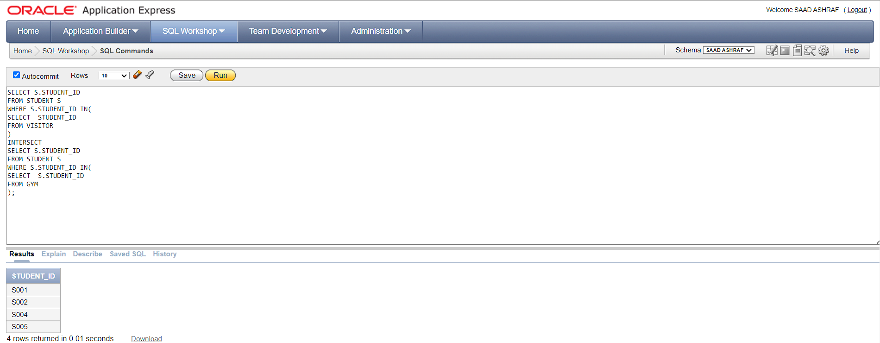

**Question No # 05**

**• Case Study 1:**

Suppose that the Hostel Management wants to restrict the access of the ADMIN table to

only those users who are designated as "Super Admin". They want to grant SELECT,

INSERT, UPDATE, and DELETE privileges to only those users who have the designation

of "Super Admin".

**SOLUTION:**

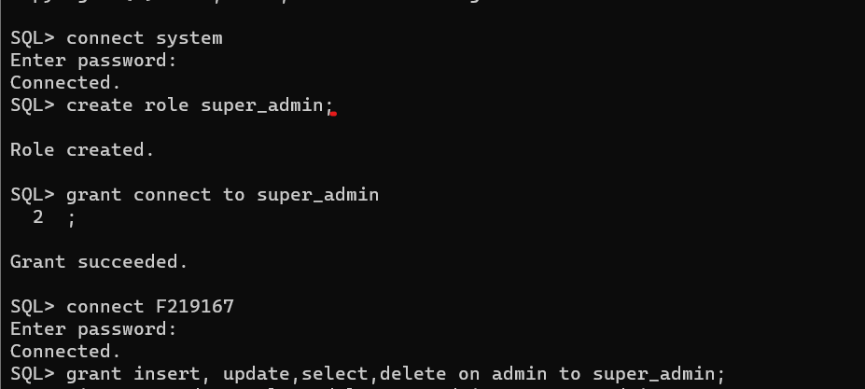

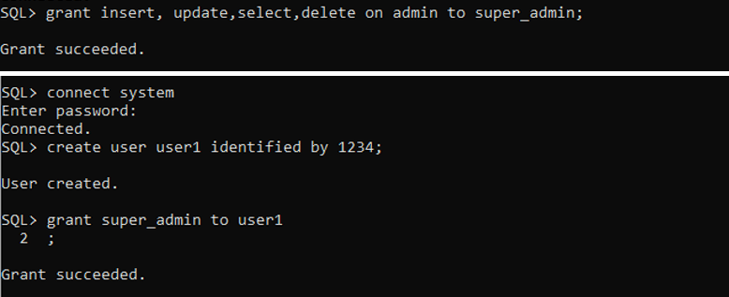



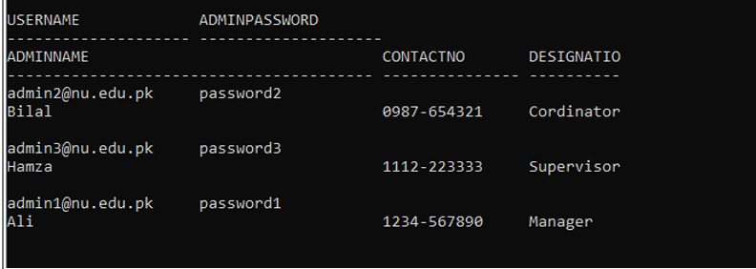

**• Case Study 2:**

A Firm is managing multiple hostels for its Residents. The management wants to restrict

access to the hostel database for different users based on their roles and responsibilities.

The following roles have been defined:

o Coordinator: Full access to all tables

o Manager: Read and Write access to Student, Room and Visitor tables

o Supervisor: Read access to Student, Room and Bill Collection tables, Read and

Write access to Maintenance table

**SOLUTION:**

